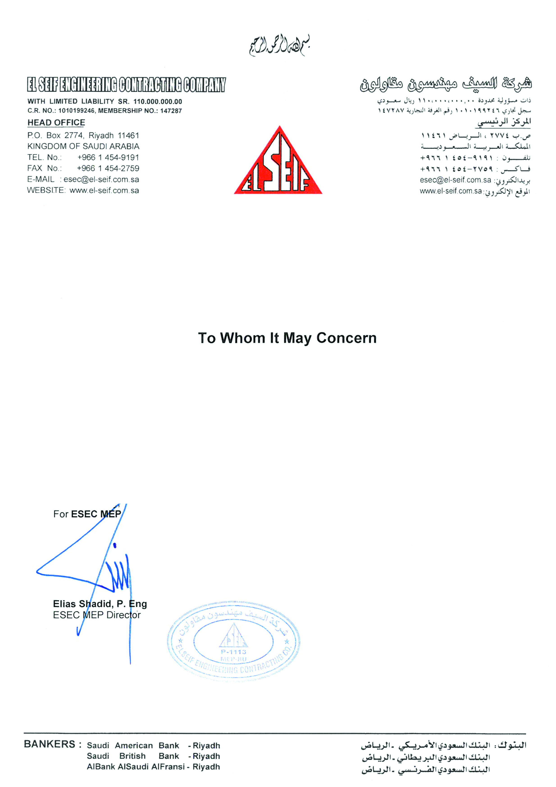

**Date: <To>**

It is certified that Mr. <Name> <fname> Passport Number <Passport> worked with us as a <Designation> in EL SEIF Enigneering from <From> to <To>.

During his services period we found him hardworking intelligent and having vast experience in this field.

He left the services on his own accord.